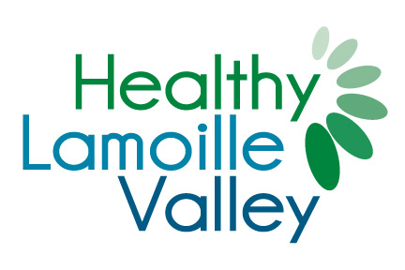

**Healthy Lamoille Valley - Application for Funding**

**Name of Applicant: _______________________________________________**

**Contact Person: __________________________________________________**

**Email: _______________________ Phone: __________________**

**Mailing Address: __________________________________________________**

**__________________________________________________**

**Location of Project/ Activity: _________________________________________**

**Category for which you are requesting funding:**

□ Healthy Foods □ Bike and Pedestrian Friendly Communities

□ Parks and Recreation □ Healthy Lifestyles/Fitness Related Activities

**Please provide a summary of the project and/or activities for which funds are being requested.**

**List other funding sources and/or other community partners involved in this project.**

**What is the size and demographics of the population that will be reached by implementing this project and/or activity? Describe the demonstrated community need that this project seeks to address.**

**Amount requested: (Up to $500)**

**How will you determine if your project was a success?**

**Please share your success stories with us!**

**Please email completed forms to: kate@healthylamoillevalley.org**